Project Report for Berkeley Extension Data Analytics Bootcamp

Team :D

Team members:

Justin Agogbua

Ran Bi

Shuai Li

Contents:

1. Executive Summary
   1. Purpose of this report
   2. Aims and objectives
2. Approach and data used
   1. Scope of data
   2. Approach
3. Findings
4. Conclusion and recommendation
5. Executive summary
   1. Purpose of this report

This report serves as the report for Project One, to fulfill the requirement of Berkeley Extension Data Analytics Boot Camp.

* 1. Aims and objectives

With the economy booming, the San Francisco Bay area housing price had increased dramatically during the past several years, thus we were curious whether the population, housing price and business locations affect with each other. There are lots of questions such as, whether people are willing to take the traffic to avoid the sky-high housing price, whether the business locations have correlation with the housing price, whether the government buildings and community facilities have anything to do with the housing price.

In this project, we were trying to answer below questions (testing the hypothesis):

* Area’s with Higher median housing prices are like vortexes in the bay area, they pull in people and businesses into their center. Is this true?
* What type of businesses are more prevalent in the most expensive areas?
* Do large groups of people commute to area’s with higher housing ?

1. Approach and data used.

2.1 Scope of data:

We partitioned the data source into three parts: population & housing price, the business locations, and the transportation.

2.1.1 The population and housing price data are from Census API, we explored the median housing prices in bay area (by zip code), the data was up to 2016. Although the 2017 data was not available, we did verify on Zillow that the housing price trend remained same per zip code during the past two year, so the heat map plot of housing price for the 2016 data should be representative for the current situation as well.

2.1.2 The business location data is from Google Places API. This part of data has limitation:

Limitation 1: Business is pre-defined by “type” in the API, we can only add up restaurants and café and bars, but we cannot specify specific search as “IT companies”, etc.

Limitation 2: Per Google Places API service agreement, only up to 60 data points per location per business type can be accessed. As a result, the data we were able to get for many business types are not exhaustive. For instance, we are able to get 60 supermarkets per city, and the location of the supermarkets can be accessed, but since this is not exhaustive data, no conclusion can be made on whether population has correlation with number of supermarkets each city has.

* + 1. The traffic data

We get our traffic data from google map API. We can setup the start locations (A) and end locations (B), and the time periods. The google map API gives us the average commute time people spend from A to B at that time. We setup the cities based on bay area’s zip code, and for each city we setup it as the start location and end location. Then we collected all the data for commute time vs distance at morning and evening peak and off-peak time.

The traffic data in the google heat map are snapshot data on individual time point captured recently, it can represent the general weekday peak vs. off-peak traffic in the bay area, but not a quantitatively accurate representation of the bay area traffic.

2.2 Approach:

We put all three aspects of data together, tried to analyze the relationship in-between each other.

We explored what type of business are more prevelant by looking at median housing prices by zip code and comparing business concentration around the bay area. We also looked at expected traffic between counties during morning and evening peek and off peek hours in order to understand whether people commute to live in area with slightly lower houisng price.

1. Findings
   1. Housing Price v.s. Population Density Heat Map

The left plot below from google map API shows the housing price in the San Francisco bay area, with red denotes the most expensive area, followed by yellow, and green denotes the relatively cheaper area.

The right plot below shows the population density in the San Francisco bay area, with red denotes the highest population desity, followed by yellow, and green denotes the lowest.

The housing price and population density location generally match each other at the peak locations, which verifies the suply-demand theory, when the demand is higher, the price is boosted. But the plot also shows that the population density’s peak area (in read) slightly spread out and gets larger than housing price plot, for each city in bay area. It tells us that people try to stay close to where is most attractive for them, but if the housing price is too high, they tend to move slightly further. One more observation from the comparison of the two plots is that, San Jose has more population density for the area where housing price is not that expensive. We’ll further explore in next section, regarding business locations.

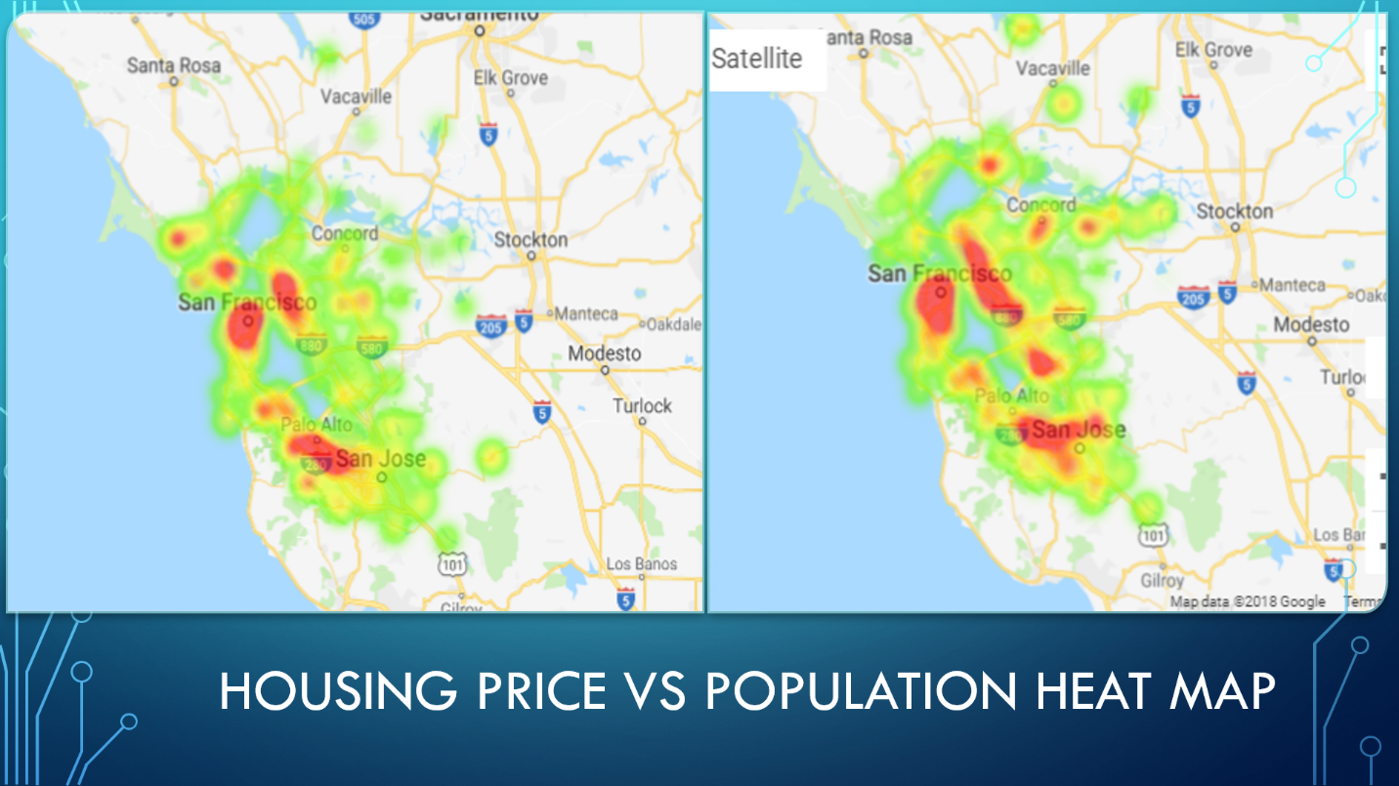

* 1. Schools v.s. Housing Price and Population density map

From the plots, it’s quite obvious that schools locate at where the population are. We wanted to understand whether school locations correlate with housing price, but the plots show that school locations are more related to population density than housing price. This is due to the data source limitation, the Google Places API has the type “school” included all kinds of tranining schools and tuitions. If we can pull data on school ranking, and plot school ranking v.s. housing price, it might be a different story.

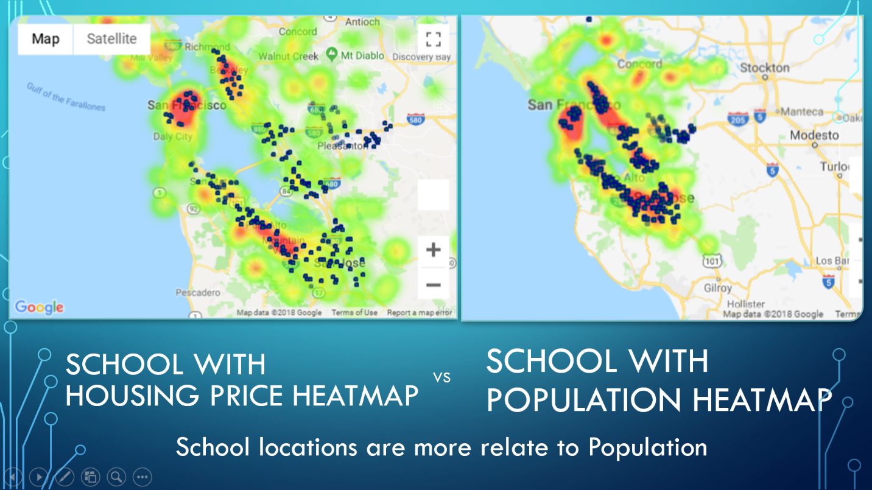

* 1. Public Facilities v.s. Housing Price and Population density map

Below plots combine the government buildings, city halls and hospitals and plot against housing price and population density. Although it’s non-exhaustive data for hospitals, it still correlate quite well. Public facilities, including government buildings and hospitals are located at where the populations are.

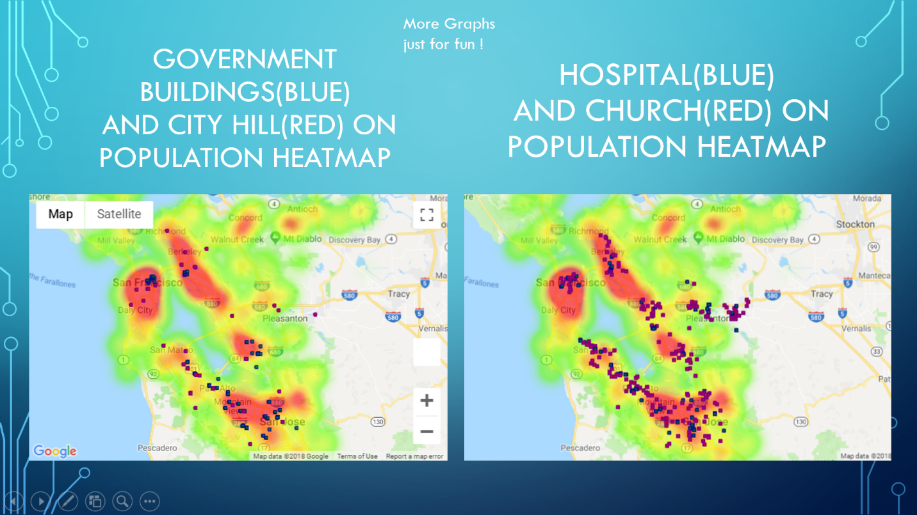

* 1. Supermarkets and restaurants

Below plots compare supermarkets and restaurants location agains housing price and population density. Although it’s non-exhaustive data on supermarkets and restaurants, we can still tell that both supermarkets and restaurants locations are more relevant to the population density than the housing price.

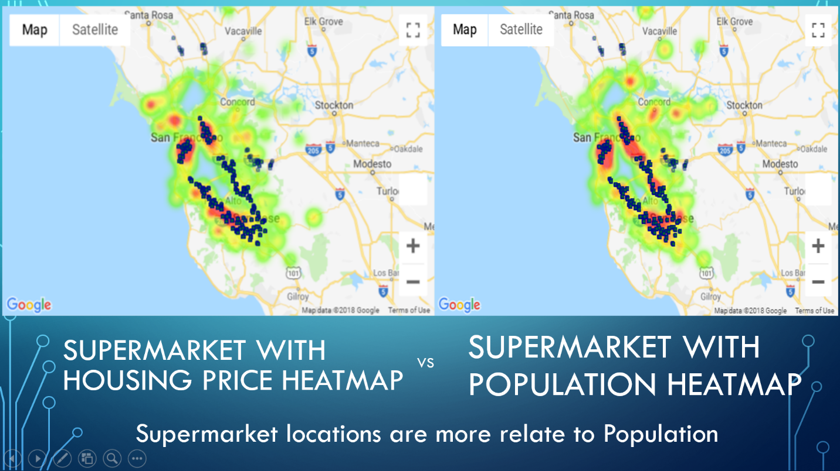

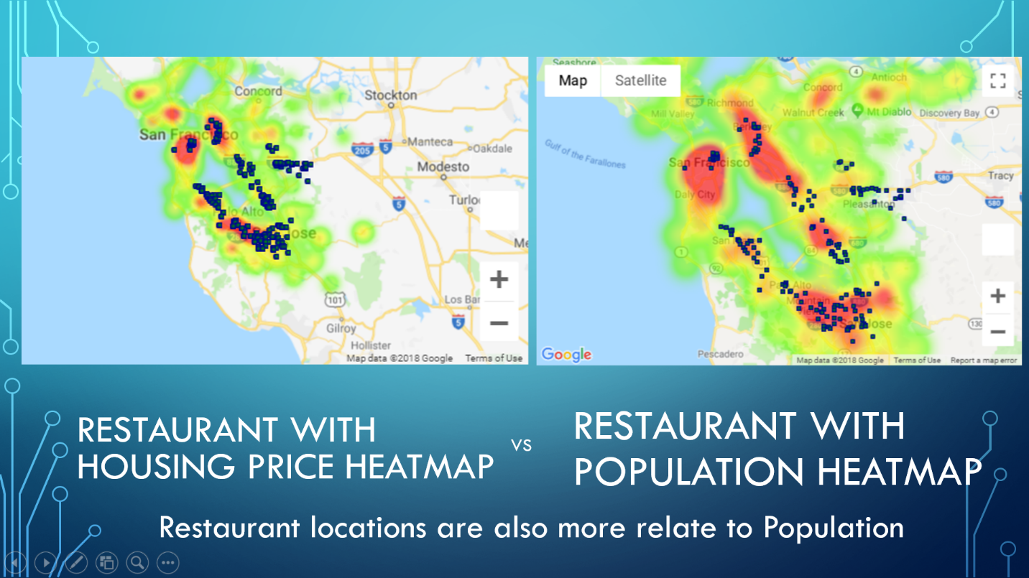

* 1. Supermarkets and Department Stores

We also explored whether similar types of business have sime ditribution on the map, and whether they have the same correlation with population. The plot below provides and answer YES.

In the plot below, the supermarkets which are represented by blue dots and department stores which are represented by red dots stay close to each other in every city in the San Francisco bay area.

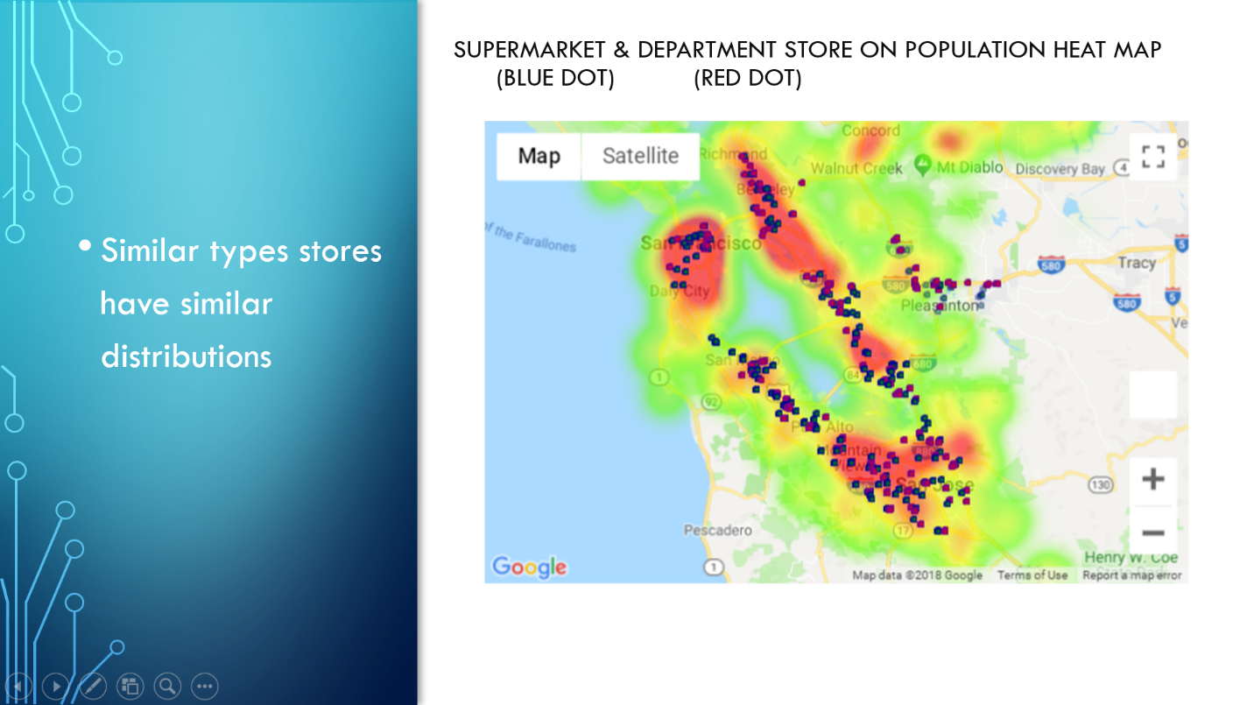

* 1. Traffic data

We also looked at expected traffic between counties during morning and evening peek and off peek hours. It shows that people spend more time at peak traffic then the off-peak traffic.

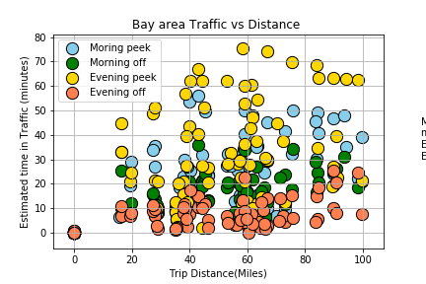

Also, as we can see clearly that the morning up-flow times are much more than the down-flow times, and at evening it is the opposite way. It can prove that large groups of people commute to area’s with higher housing,





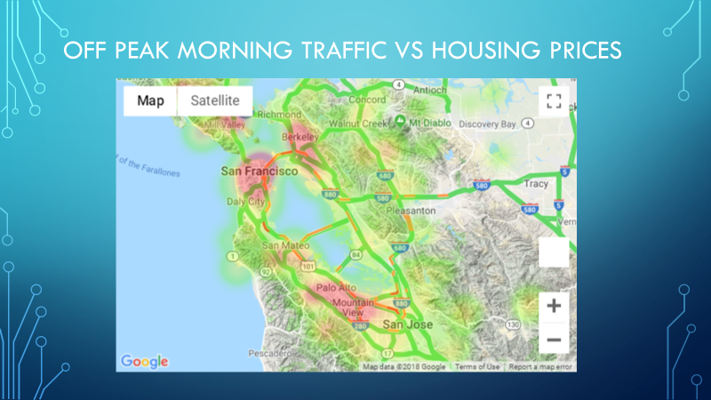

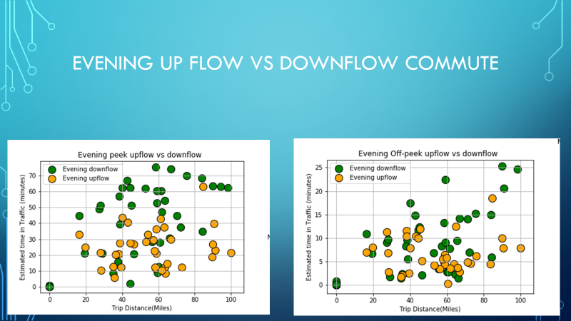

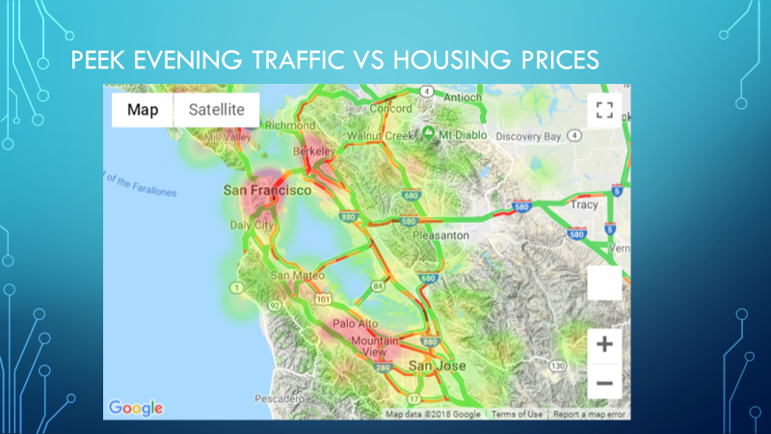



Conclusion and Recommendation

Due to the limitation of the data and the scope of this project, we were looking predominately at correlation not causation, as our data is mostly snapshot data, which is predominantly built on a single point in time (especially traffic data). We also had limits on the amount of location data we could pull, so some of our data is samples rather than the whole picture. However, base on the data we have, we can conclude that:

1. There seems to be some correlation with high housing prices and populations.
2. The distribution of the business as well as public facilities are more related to the population than housing price.
3. There also seems to be more time spent in traffic during commute hours headed towards area’s with higher housing prices rather than leaving from them.

If the budget allows, more accurate exhaustive data for busimess can be purchased on a yearly basis, thus conclusion may be made on whether housing price have drifted business year by year. Also, as mentioned earlier in the report, if more accurate school data can be aquired, better conclusion on how school ranking affect housing price can be explored.